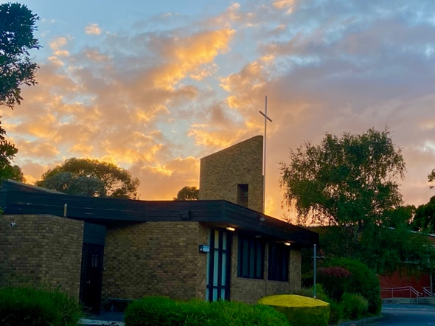

HOLY FAMILY CATHOLIC PARISH
Mount Waverley

Child Safety in our Parish

At Holy Family Parish Mount Waverley all children have the right to feel safe, participate in parish life and be happy.

If YOU feel unsafe (this may be any form of ‘hurt’ including physically or emotionally) in the parish community you can:

- Speak to a member of the Child Safety Team
Natalie Sillato and Janet Cullinan (9807 9494)

- Speak to our Parish Priest Father Justel Callos (9807 9494)

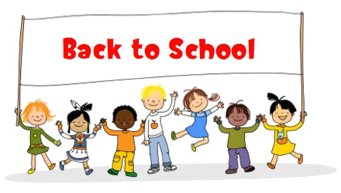

What will happen?
- You will be listened to
- You will get some help so that you are safe

Holy Family Catholic Parish Mount Waverley is committed to the protection of children
The safety, well-being and inclusion of children in our Parish is of the utmost importance and everyone in the Parish is encouraged to play a personal role in ensuring these aims are achieved at all times.

